Ideation Phase
Define the Problem Statements

Date | 17 February 2026
Team ID | LTVIP2026TMIDS90124
Project Name | DocSpot: Seamless Appointment Booking for Health
Maximum Marks | 2 Marks

Problem Statement -1:
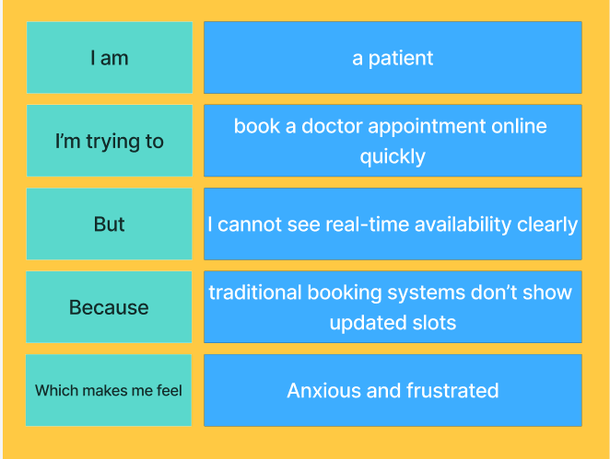
Problem Statement -2:
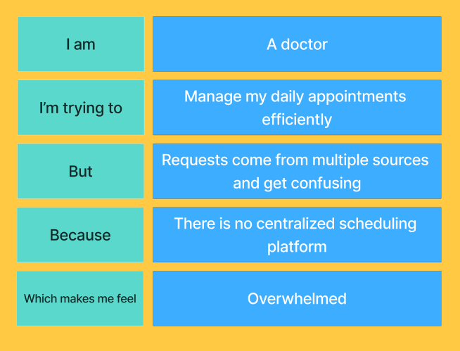

Problem Statement (PS) | I am | I’m trying to | But | Because | Which makes me feel
PS-1 | A patient | Book a doctor appointment online quickly | I cannot see real time availability clearly | Traditional booking systems don’t show updated slots | Anxious and frustrated
PS-2 | A doctor | Manage my daily appointments efficiently | Requests come from multiple sources and get confusing | There is no centralized scheduling platform | Overwhelmed

